Linux Practical

Where am I and what’s there?
At the command line, print the current working directory to find out where you are:
pwd
You should see a result of the form: /home/username – this directory is known as your home directory. Take a note of it; you will need it later. Also note that we’ll use username (in italics) a lot in this practical. Whenever you see it, you should replace it with your actual username.
Now have a look at the root (slash) file system. The cd (change directory) command will get you there:
cd /
Enter the following command, which lists the contents of the current directory:
ls
You should see something resembling the following:
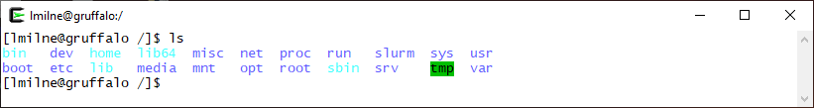
See if you can use cd to navigate from the root back to your home directory at /home/username.
Once back home (just type cd on its own if you get really lost), list the contents of your home directory. It may not have much in it if you’ve not used the cluster before.
Hint: Where am I!?
If you get lost, typing pwd (for “print work directory”) will always tell you where you are, but you can also take a glance at the SSH window’s title bar – many common tools will mirror your current directory there.

Navigate to your “scratch” directory
Now move into your “scratch” directory. This is an area of your storage where you should do most of your working. Note that the scratch directory is not backed up.
To move there, first ensure you are in your home directory (type cd on its own to go there) and then type:
cd scratch

Make a directory for the training course
In your scratch directory, and at the command line, type:
mkdir training
This will make a directory called “training” - confirm it’s been created by using the ls command.

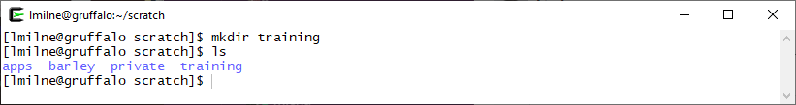

Change to the training directory
Let’s use the new directory. To do this, enter:
cd training
Now where are you? Remember you can always find out with pwd.
You should be at /home/username/scratch/training
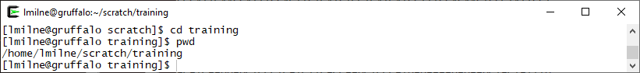
Type at the command line:
cd ..
Now where are you?
Note that .. is a special directory that moves you up one level in the directory tree. A single dot . means the current directory, and a double-dot .. means the parent directory.
You can combine multiple “move up one level” shortcuts into a single cd command, eg:
cd ../../..
Chances are this put you right back to the root (/) directory again, so move back home with cd.
Pay attention to the title bar in your SSH client window too – it will track the current directory for you too. If it shows the ~ character, that’s ok, as ~ is a special shortcut for your home directory.
Hint: Using the mouse in the command line
You can’t click the mouse cursor around the Linux command prompt like you’re used to, but it does still offer basic cut and paste. Drag with the mouse to highlight text, then simply right-click to paste it back into the window. You can also double-click a word (eg a filename) and instantly copy it into your current command with a right-click.

Create a directory
Return to the training directory. If you are a bit lost you can go there by typing cd to go into your home directory, then changing into the training directory like this:
cd
cd scratch/training
Or you can use the ~ shortcut as part of the path to the training directory in a single command:
cd ~/scratch/training
Hint: Special keys
Typing long file or directory names is annoying, but luckily there’s an easier way. You only need to type part of a name and then hit the TAB key – Linux will autocomplete the rest of it for you. You can also use HOME to jump the cursor to the start of a line, and END to jump to the end of a line.

Within training create another new directory by typing at the command line:
mkdir mynewdirectory
Confirm the new directory is there by using ls
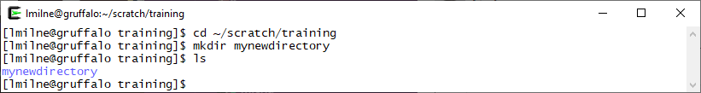

Remove a directory
Type at the command line:
rmdir mynewdirectory
Now get a listing of the contents to confirm it has been removed.

Make another directory
Make a directory call tmp in your training directory and change into it.
mkdir tmp
cd tmp

Create an empty file
Within the tmp directory, type:
touch mynewfile
This special command just creates an empty file with the given name. Now type the following command, an enhancement to the previous ls command
ls –l (note this is “minus ell” not “minus one”)
Can you work out how big the file you have created is? Or when was it created? The -l option for ls gives additional information about files.
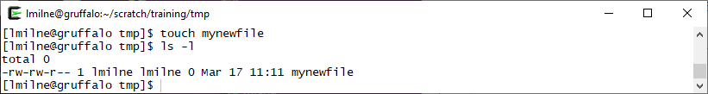
Note, you can also use ll (“ell ell”, for long listing) which is a special shortcut (or “alias”) for the same command.

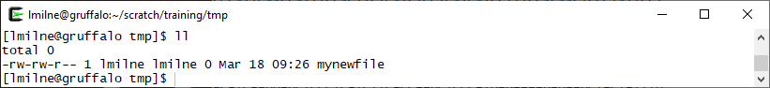
Hint: What have I done?
The up and down arrow keys can be used to scroll backwards and forwards through recently entered commands. Resubmit a command by hitting ENTER, or even edit and then resubmit – this is great for when you’ve mistyped a long path and need to try again without having to retype everything.
You can also use the history command to display a recent history of everything you’ve typed:
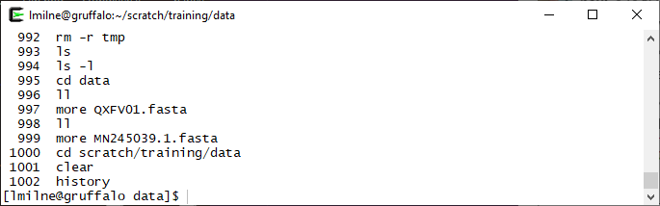
If you see an entry you want to re-run, use the ! (always called “bang” in the Linux world), followed by the number of the command as shown by history. For example:
!997
You can use !! (two bangs together) to instantly repeat the previous command.

Edit a file
You can now edit the empty file using the text-editor nano. This is useful for editing README files, configuration files, scripts and so on. To edit a file using nano simply type
nano mynewfile
Your ssh client window should now look like this, and you should be able to start typing to add text to the file.
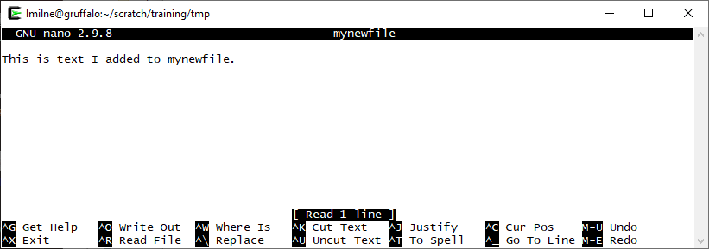
The menu at the bottom of the nano window shows a variety of options, the larger your window the more options are shown at once. For the full set of options view the help section by typing CTRL+G while running nano. As you add or edit text in nano, note that the cursor cannot be moved by clicking with the mouse but is controlled by the cursor keys on your keyboard.
To save your work, exit nano by doing CTRL+X, then it will ask if you want to save (press Y or N, or CTRL+C to cancel) and ask what the filename of the saved file should be (just press ENTER if you want to save over the same file). If you then list the directory again you should be able to see that mynewfile is no longer an empty file.

Copy a file
Make sure you’re still in your /home/username/scratch/training/tmp directory, and then type:
cp mynewfile anothernewfile
The cp command will make a copy of a file.
Confirm that anothernewfile has been created and that it is the same size as the original mynewfile. Are the creation dates and times the same? (Note: If you did the last couple of steps very quickly they may be the same but anothernewfile should be newer than mynewfile.)
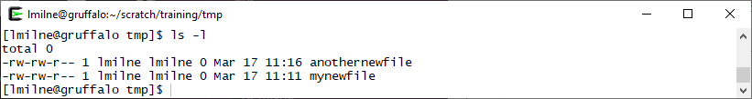

Move a file
In your /home/username/scratch/training/tmp directory, type:
mv anothernewfile ~
Confirm that the file is no longer in the current directory. 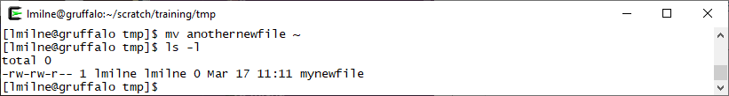Now check to see if it is in your home directory with:
ls -l ~
Remember, ~ (tilde) is an alias for your home directory. It can save you having to type /home/username all the time.
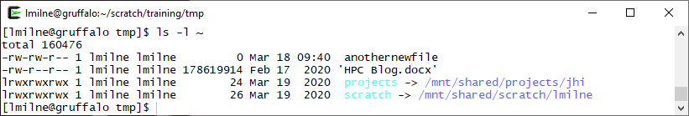
Now move the file back with the following command
mv ~/anothernewfile .
Remember the . means the current directory, so this command in full has really asked for /home/username/anothernewfile to be moved to /home/username/scratch/training/tmp/anothernewfile

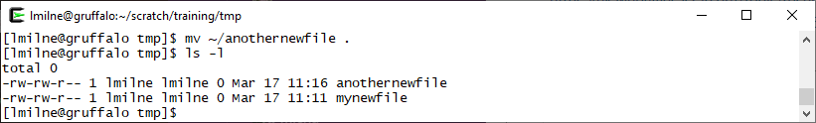
Now move up one level to the ~/scratch/training directory
cd ..

Copy files
You can copy directories of files by supplying cp with the -r argument. The general form of this is cp -r source_directory destination_directory.
You can use this to take a copy of all the tutorial files and store them locally in your training directory:
cp -r /mnt/shared/training/data ~/scratch/training
This will take a few moments to run.
The -r option means recursively copy the directory, that is, copy the directory, its files, and any sub-directories (and their files) within it. Remember that ~ means your home directory, so what we’ve asked for is for the data directory located in /mnt/shared/training to be copied to your scratch/training sub-directory within your home directory.
Check that the data directory has copied to the training folder using ls -l
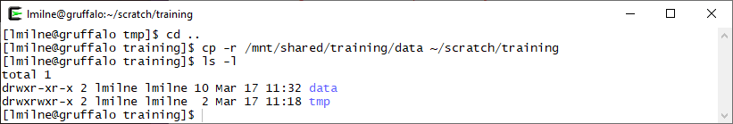
Move into the data directory.

Revisiting ls
ls has lots of useful options (that work alongside -l), such as:
-h list file sizes in human-friendly KB, MB, etc
-S list (and sort) files by size
-a show hidden files as well
Note the capital -S in the second row. That isn’t the same option as -s (small s). Linux is case sensitive and it’s really important to pay attention to this.
The -a option is another interesting one as it lists hidden files. In Linux, that’s any file whose name begins with a dot, for example .testHiddenFile – Enter:
ls
Then enter:
ls -a
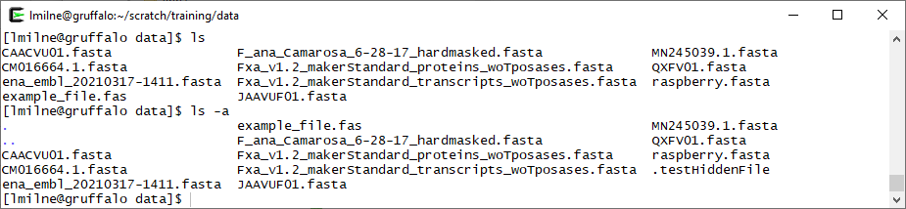
It’s worth noting that some of the command line options only work in conjunction with others. For instance the output of ls -h will look no different than the output of ls. Combine it with ls -l though e.g. ls -l -h and the sizes specified in the ls -l output will be shown in a human readable format, rather than just the raw number of bytes (which for large files will be in the millions).
Some tools allow you to combine command line options, eg ls –lh although if in doubt, just specify options separately as in the first form above.
At the command line enter:
ls –lS
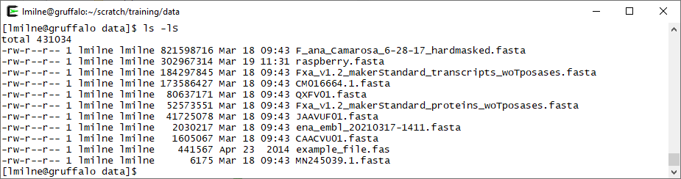
(Remember case sensitivity, that’s a capital S). Note in the image above that the output of ls differs from that of ls -S (but only in the ordering of the directories, the default ordering of ls is alphabetical). In the ls -lS example we can confirm that the files have been listed in size order (largest to smallest).
Many common tools and programs on Linux come with built-in help manuals – meaning we can check on what other options ls has by running:
man ls

Viewing a file
You can view the contents of files on linux using the more command. Check you’re still in the data directory (run cd ~/scratch/training/data if not). If you list this directory, there should be a file called example_file.fas
Let’s view it now:
more example_file.fas
You should see a lot of text on the screen, as below.
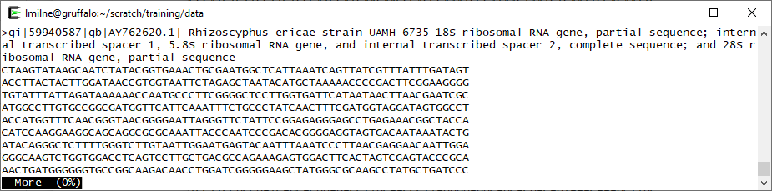
You can scroll through the file by holding down the return key on your keyboard, or move through the file a page at a time by pressing the spacebar. You can return to the command prompt by pressing q or CTRL+C.

Peeking at a file
There are two other really useful tools for viewing files – these are head and tail.
You can use head to quickly view the contents of the start of a file:
head example_file.fas
You should see that the first ten lines of the file have been displayed (although there may be some line wrapping depending on your SSH client’s window size).
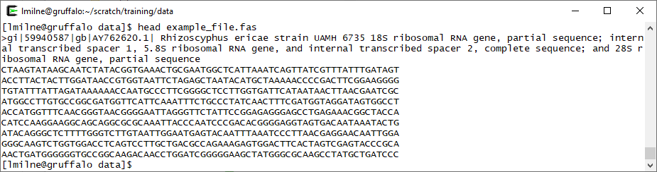
Take a look at the man page for head (using man head) to see which options are available. Try to view the first twenty lines instead of the default ten.
tail is very much like head, but instead it enables you to view the end of a file. Enter:
tail example_file.fas
If you read the man page for tail (man tail) you’ll note that it has a few more options than head. An interesting option for tail is -f which follows the end of the file as the file is growing. This can be really useful for following along with the output of a long running program.

Navigation reminder
Change back into the tmp directory you were previously in. There are a few ways you can do this, so pick one from the following:
You can use the .. shortcut to move up one directory level:
cd ../tmp
Or, use cd to return to your home directory, then supply it with the relative path to the tmp directory:
cd
cd scratch/training/tmp
Or, use the absolute path to the tmp directory, which will work from any directory you’re currently in:
cd /home/username/scratch/training/tmp

Rename a file
Earlier you created two files anothernewfile and mynewfile in the tmp directory. List it using ls to confirm they’re both still there.
The mv (move) command can also be used to rename a file. For example:
mv anothernewfile correctname.txt
and use ls as always to check that things are as you expect.
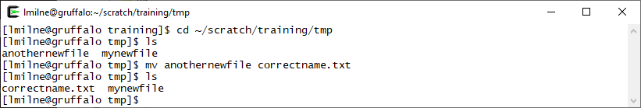

Delete a file
The first thing to remember on almost all Linux file systems, is once you have a deleted a file it is gone! There is – usually – no recycle bin at the command line, so be careful.
Type the command:
rm correctname.txt
Check by listing the files that it really has gone.

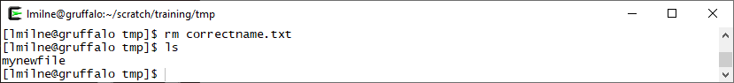

Revisiting deleting directories
Return to your training directory again.
cd ~/scratch/training
Earlier you saw that rmdir will delete a directory, however it can only do so if the directory is empty. You’re finished with the tmp directory and don’t want that data clogging up the system anymore, so you want to delete the directory, but it’s full of files and rmdir refuses to do the job…
Fortunately, rm accepts an additional (recursive) option which will let you remove a directory and all of its contents in one go:
rm –r tmp
To prove it’s gone, list the current directory. You should no longer see tmp in the directory.
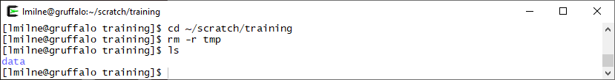
If you have time, why not try creating and deleting a few more files and directories for practice?

